**THE CELL STRUCTURE, REPLICATION, TRANSPORT and METABOLISM**

**Question 1**

Energy for cellular metabolism is supplied in the form

1. Adenosine Diphosphate.
2. Adenosine Triphosphate.
3. Deoxyribonucleic Acid.
4. Endoplasmic Reticulum.

**Question 2**

The cell membrane

1. uses energy to move solutes passively across it.
2. actively transports water in and out of the cell.
3. uses carrier molecules to move solutes against its concentration gradient.
4. actively transports large molecules into the cell but not out of the cell.

**Question 3**

Mitosis

1. occurs only in cells with cell walls.
2. produces cells which are identical to the parent cell.
3. results in daughter cells with half the number of chromosomes of the parent cells.
4. results in daughter cells with twice the number of chromosomes of the parent cells.

**Question 4**

Anaerobic respiration results in the formation of

1. Carbon dioxide.
2. Lactic acid.
3. Triphosphate.
4. Adenosine diphosphate.

**Question 5**

Rough endoplasmic reticulum is

1. characterised by the presence of ribosomes.
2. generally arranged in layers.
3. connected to the nucleus via smooth endoplasmic reticulum.
4. the site where ATP synthesis occurs.

***The next two questions refer to the diagram below.***

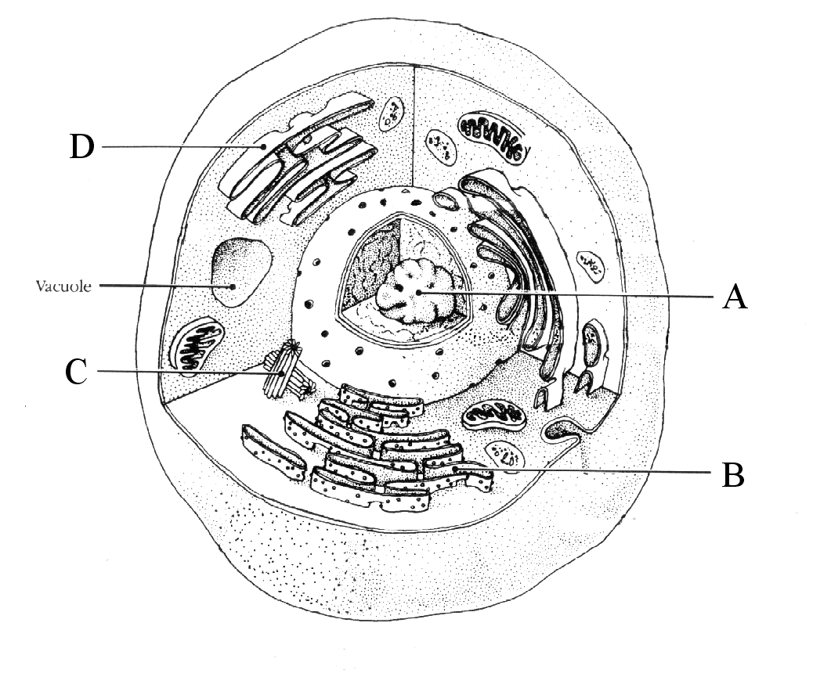

**Question 6**

Which of the following correctly identifies the structures **A, C** and **D** in the diagram above?

|  |  |  |  |
| --- | --- | --- | --- |
|  | **A** | **C** | **D** |
| a. | Nucleus | Mitochondria | Endoplasmic Reticulum |
| b. | Nucleolus | Mitochondria | Golgi Apparatus |
| c. | Nucleolus | Centrioles | Golgi Apparatus |
| d. | Nucleus | Centrioles | Endoplasmic Reticulum |

**Question 7**

Structure **B,** a ribosome,

1. facilitates protein synthesis.
2. produces cellular energy.
3. facilitates mitosis.
4. removes wastes from the cell’s nucleus.

**Question 8**

If the nucleolus ceases to function, the cellular function first affected would be

* 1. protein synthesis.
  2. cellular respiration.
  3. ribosome production.
  4. storage of chromosomes.

**Question 9**

Which of the following is **NOT** a characteristic of prophase?

* 1. The chromosomes become visible.
  2. The centrioles form spindles.
  3. The chromosomes have replicated.
  4. The nuclear membrane has reformed.

**Question 10**

A student is observing bacteria using a microscope. The field of view at low power (100x) is 2mm and the bacteria are approximately 50 micrometres in size. She switches the objective lenses to 40x making a total magnification of 400x. The field of view and the bacteria size would now be

* 1. 500 and 50 micrometres respectively.
  2. 1000 and 50 micrometres respectively.
  3. 50 and 10 micrometres respectively.
  4. 500 and 10 micrometres respectively.

**Question 11**

When a tissue was examined under a light microscope using a 40x objective lens, twenty-four (24) cells across the field of view could be observed. The diameter of the field of view is 360µm. What is the average width of each cell?

1. 15µm.
2. 150µm.
3. 30µm.
4. 3 µm.

**Question 12**

If the same tissue, in question 10, was to be viewed with a 10x objective lens, the number of cells across the field of view would be approximately

1. 6.
2. 12.
3. 48.
4. 96.

**Question 13**

Which of the following are types of movement across the cell membrane requiring energy?

1. Facilitated diffusion, active transport, pinocytosis.
2. Osmosis, phagocytosis, exocytosis.
3. Endocytosis, exocytosis, pinocytosis.
4. Phagocytosis, pinocytosis, facilitated diffusion.

**Question 14**

1. Complete the following table outlining the main differences between aerobic and anaerobic respiration. (8 marks)

|  |  |  |
| --- | --- | --- |
|  | **Aerobic Respiration** | **Anaerobic Respiration** |
| Oxygen present (yes/ no)? |  |  |
| Name(s) of separate reaction steps that take place? |  |  |
| Location of each reaction in the cell? |  |  |
| Products formed at end? |  |  |
| How much ATP is produced? |  |  |
| Occurs during rest or physical activity? |  |  |

1. A white blood cell is placed into a hypotonic solution as shown in the diagram below.



1. Use an arrow to indicate on the diagram above the net movement of water.

(1 mark)

1. Explain why the water moves in this direction. (2 marks) ________________________________________________________________________________________________________________________________________________________________________________________________
2. With reference to the structure of the cell membrane, compare the above process with facilitated diffusion. (3 marks)

________________________________________________________________________________________________________________________________________________________________________________________________________________________________________________________________________________________________________________________________________________________________________________________________________________________________________________________________________________________________________________________________________________________________________________________________

**Question 15**

Metabolism (the sum of all the chemical changes that occur in a living organism) falls into two parts: **anabolism,** which consists of energy-requiring reactions involving synthesis of complex molecules, and **catabolism** consisting of energy-yielding reactions in which complex molecules are broken down.

**ATP** is the link in the **transfer of energy** from catabolic reactions to the anabolic ones.

Figure 1 is based on the information in the above paragraph.

Simple Molecules

2

Complex molecules

ADP + P

3

4

1

Complex molecules

Simple Molecules

(a) Add four arrowheads in Figure 1 to show the directions in which the two coupled reactions occur. (2)

(b) For the boxes 1 to 4 state the term from the bold print in the passage.

Box 1: _______________________________________ (½)

Box 2: _______________________________________ (½)

Box 3: _______________________________________ (½)

Box 4: _______________________________________ (½)

(c) The human body produces ATP at a rate of approximately 400g/hour, yet at any given moment there is only about 50g of ATP present in the body. Explain why. (2)

**Question 16**

Meiosis and mitosis are both forms of cell division but their roles and biological significance are quite different.

(a) Which of these processes is involved in the production of genetically identical cells?

______________________________________________________________________ (1)

The following diagram shows an event, related to cell division, occurring in a cell.



(b) Name the structures labelled:

U ________________________ (1)

V ________________________ (1)

(c) Name the type of nuclear division (i.e. meiosis or mitosis) and the stage of division shown.

______________________________________________________________________ (2)

**Question 17**

The graph below shows the changes in the amount of DNA in a cell during one mitotic cycle.



A

B

C

D

E

F

(d) What stage, or stages, of mitosis occur between:

A-C _________________________________________________________ (1)

D-E _________________________________________________________ (1)

(e) If the amount of DNA present in a cell at metaphase in mitosis is 10 units, how much DNA will be present in each nucleus immediately following telophase?

_______________________________ (1)

Explain your answer.

(2)

**Question 18**

1. DNA is present in all diploid cells in the body and controls the activities each cell performs. As a result it is important that DNA is able to make identical copies of itself before mitosis can be carried out. (8)
2. Describe the structure of DNA and where it is located in the cell. (8)
3. Explain how DNA is replicated when the cell is in interphase. (4)

**Question `19**

In order for diffusion to occur there must be a concentration gradient present.

1. Explain what is meant by the term diffusion, incorporating your understanding of what a concentration gradient is. (4)
2. Explain why concentration gradients are important to the functioning of the lungs and how a concentration gradient is maintained between the circulatory and respiratory system. (12)

**Question 20**

1. Nutrients, gases and wastes must move in and out of the cell for cells to function effectively. Discuss the movement of substances in and out of cells by diffusion, active transport and osmosis. Give **ONE** example of each transport method stating where it occurs in the body. (10)
2. Explain what semi permeable means and list the three ways substances can cross a semi permeable membrane. Explain how each method works and give an example of each from the human body. (10)

**Question 21**

1. Cellular respiration is the process by which glucose is broken down in cells to produce energy that may be stored in adenosine triphosphate (ATP). Compare the **TWO** types of cellular respiration including the reactants, their word or chemical equations, where they occur, any waste substances produced and the relative amounts of energy produced. (12)